

APPLICATION FORM 2019
14th YOUNG&KIDS – Theatre for young people
Lugano 27 september - 6 october 2019

NOTICE: please, fill out one application form for each production
All documents have to be sent EXCLUSIVELY by e-mail

Name of the company/of the performer:
Primary Contact name:
Address:
City:
Phone: Mobile:
Email: Web:
Title of the show:
Date of its debut:
Cachet:
Genre:
Age range:
Language/s:
Duration:
Nr. of performers: Nr. of technicians:
Time of set up: Time of breaking down:
Previous participations to seasons or festivals with this show:
.
.
.

Dates and places where it will be possible to view the production (by 12 April 2019)
.
.
.

Anything else you’d like to add:

This application form has to be filled in all parts, signed by a legal representative of the company and furnished with the dossier with all informations required at the points a/b/c/d/e of the Announcement. The application form must be sent by 15 april 2019 to: info:fitfestival.ch.

By signing this application, the company or artist agrees to adhere to the Festival’s regulation.
Until the selection, we expect that all the candidates will be available for the entire duration of the festival.

Place and date:

Primary Contact Signature:

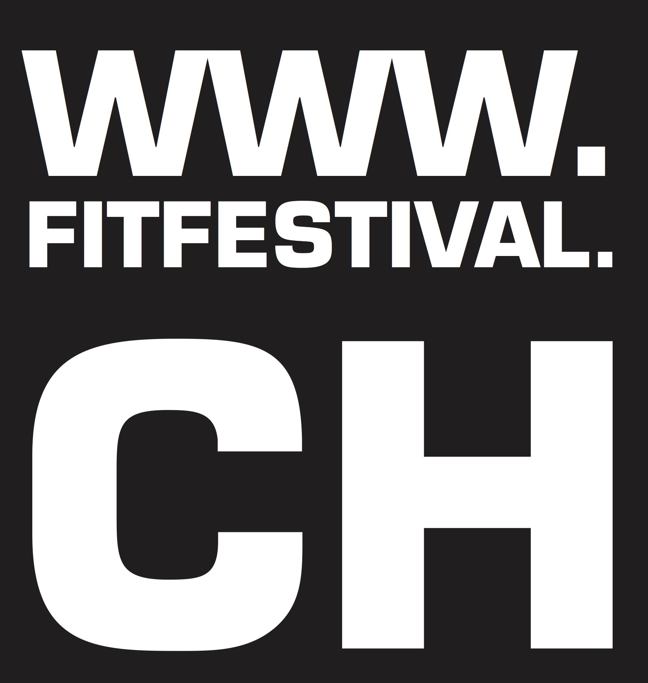

FIT Festival Internazionale del Teatro e della scena contemporanea - 6900 LUGANO
Tel. +41 91 922 61 58 info@fitfestival.ch www.fitfestival.ch

